DB.PHP
<?php
$conn = new mysqli("localhost","root","","crime_db");

if($conn->connect_error){
die("DB Failed");
}
?>

INDEX.HTML
<!DOCTYPE html>
<html>
<head>
<title>Crime System</title>
<style>
body{
background:url('a.jpeg');
background-size:cover;
font-family:Arial;
}
.box{
width:350px;
margin:120px auto;
background:#18ada6;
padding:30px;
text-align:center;
border-radius:10px;
}
.btn{
display:block;
padding:12px;
margin:15px 0;
background:#007bff;
color:white;
text-decoration:none;
border-radius:6px;
}
</style>
</head>
<body>

<div class="box">
<h2>Crime Prediction System</h2>

<a href="login.php" class="btn">Login</a>
<a href="register.php" class="btn">Register</a>

</div>

</body>
</html>

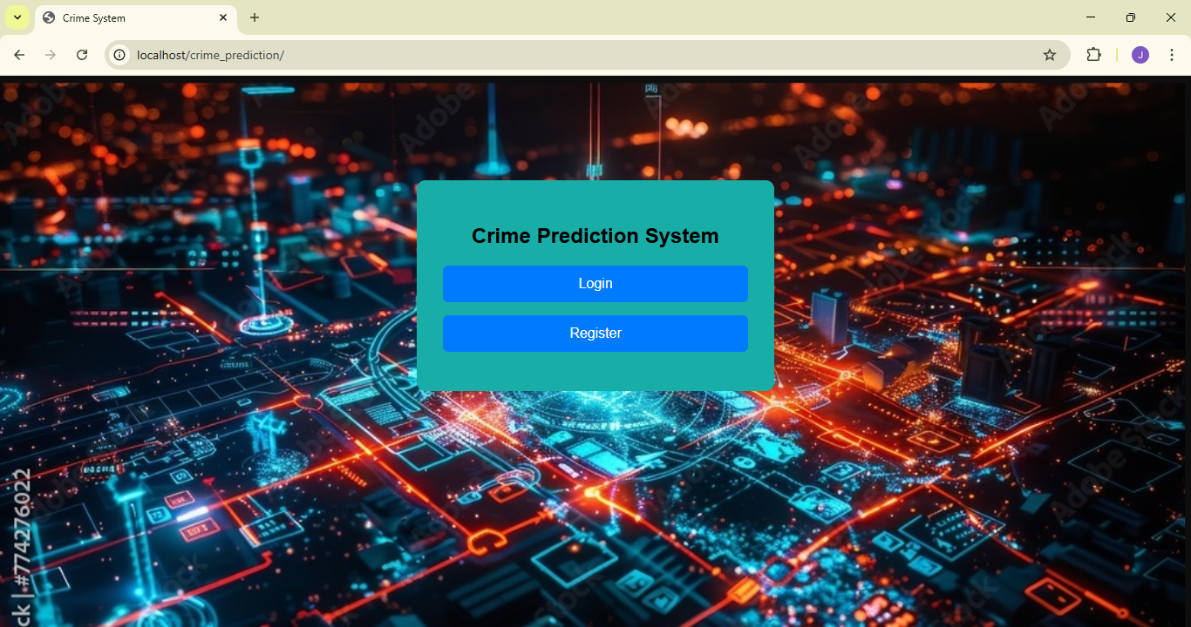

LOGIN.PHP
<?php
session_start();
include "db.php";

$msg="";

if(isset($_POST['login'])){

$email=$_POST['email'];
$pass=$_POST['password'];

$r=$conn->query("SELECT * FROM users WHERE email='$email'");

if($r->num_rows>0){

$row=$r->fetch_assoc();

if(md5($pass)==$row['password']){

$_SESSION['uid']=$row['id'];
$_SESSION['role']=$row['role'];

header("Location: dashboard.php");
exit();

}else{
$msg="Wrong Password!";
}

}else{
$msg="User Not Found!";
}

}
?>

<!DOCTYPE html>
<html>
<head>
<title>Login</title>

<style>
body{
background:url('a.jpeg');
background-size:cover;
font-family:Arial;
}

.box{
width:350px;
margin:100px auto;
background:#18ada6;
padding:25px;
text-align:center;
border-radius:10px;
}

input,button{
width:100%;
padding:10px;
margin:8px 0;
}

.msg{
color:red;
}
</style>
</head>

<body>

<div class="box">

<h2>Crime Login</h2>

<form method="post">

<input type="email" name="email" placeholder="Email" required>

<input type="password" name="password" placeholder="Password" required>

<button type="submit" name="login">Login</button>

</form>

<div class="msg"><?php echo $msg; ?></div>

<br>

<a href="register.php">New Registration?</a><br><br>
<a href="forgot.php">Forgot Password?</a><br><br>
<a href="index.html">Back</a>

</div>

</body>
</html>

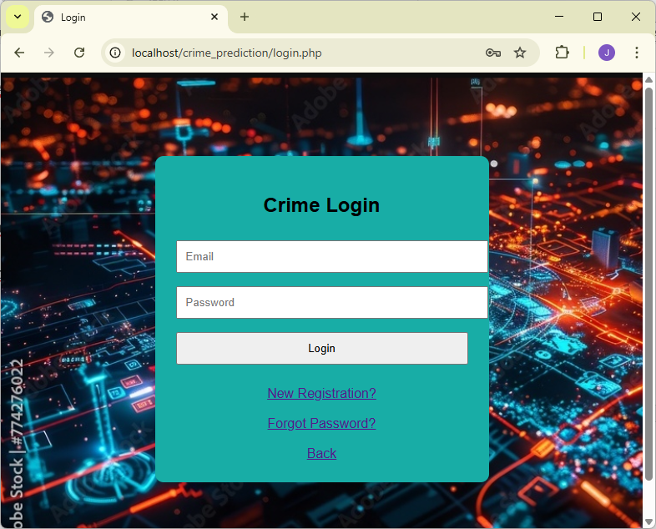

REGISTER.PHP
<?php
include "db.php";
$msg="";

if(isset($_POST['register'])){

$name=$_POST['name'];
$email=$_POST['email'];
$pass=md5($_POST['password']);
$role=$_POST['role'];

$check=$conn->query("SELECT * FROM users WHERE email='$email'");

if($check->num_rows>0){
$msg="Already Account Exists!";
}else{

if($role=="admin"){
$c=$conn->query("SELECT * FROM users WHERE role='admin'");
if($c->num_rows>=3){
$msg="Admin limit reached (3 only)";
}else{
$conn->query("INSERT INTO users(name,email,password,role) VALUES('$name','$email','$pass','$role')");
$msg="Registration Success!";
}
}else{
$conn->query("INSERT INTO users(name,email,password,role) VALUES('$name','$email','$pass','$role')");
$msg="Registration Success!";
}
}
}
?>
<!DOCTYPE html>
<html>
<head>
<title>Register</title>
<style>
body{background:url('a.jpeg');background-size:cover;}
.box{width:350px;margin:100px auto;background:#18ada6;padding:25px;text-align:center;}
input,select,button{width:100%;padding:10px;margin:8px 0;}
.msg{color:yellow;}
</style>
</head>
<body>
<div class="box">
<h2>Crime Registration</h2>
<form method="post">
<input type="text" name="name" placeholder="Name" required>
<input type="email" name="email" placeholder="Email" required>
<input type="password" name="password" placeholder="Password" required>
<select name="role">
<option value="user">User</option>
<option value="admin">Admin</option>
</select>
<button name="register">Register</button>
</form>
<div class="msg"><?php echo $msg; ?></div>
<a href="login.php">Already Account? Login</a><br><br>
<a href="index.html">Back</a>

</div>
</body>
</html>

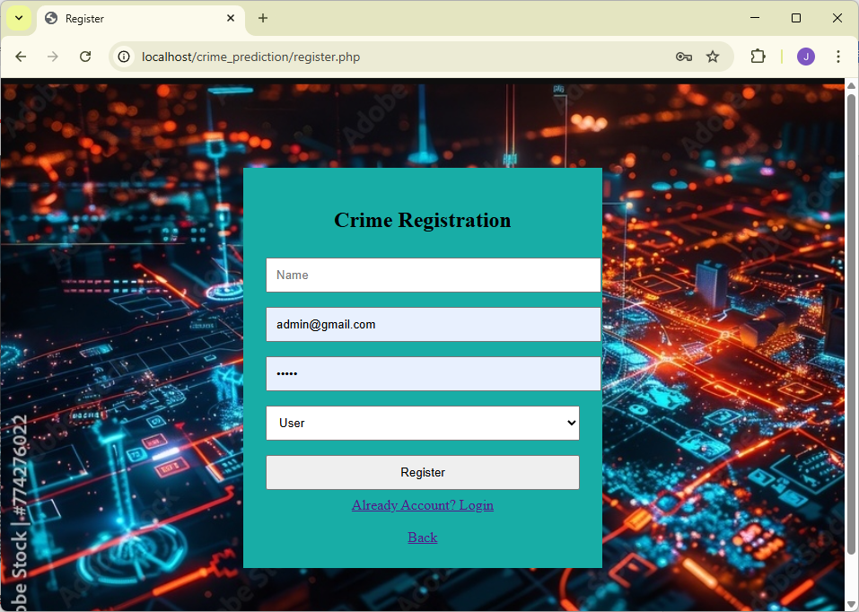

FORGOT.PHP
<?php
include "db.php";
$msg="";

if(isset($_POST['reset'])){

$email=$_POST['email'];
$newpass=md5($_POST['password']);

$check=$conn->query("SELECT * FROM users WHERE email='$email'");

if($check->num_rows>0){

$conn->query("UPDATE users SET password='$newpass' WHERE email='$email'");
$msg="Password Updated Successfully!";

}else{
$msg="Email Not Found!";
}
}
?>

<!DOCTYPE html>
<html>
<head>
<title>Forgot Password</title>
<style>
body{font-family:Arial;background:#f4f4f4;text-align:center;}
.box{width:350px;margin:100px auto;background:#18ada6;padding:25px;}
input,button{width:100%;padding:10px;margin:8px 0;}
.msg{color:red;}
</style>
</head>
<body>

<div class="box">
<h2>Reset Password</h2>

<form method="post">
<input type="email" name="email" placeholder="Enter Email" required>
<input type="password" name="password" placeholder="New Password" required>
<button name="reset">Reset Password</button>
</form>

<div class="msg"><?php echo $msg; ?></div>

<br>
<a href="login.php">Back to Login</a>

</div>

</body>
</html>

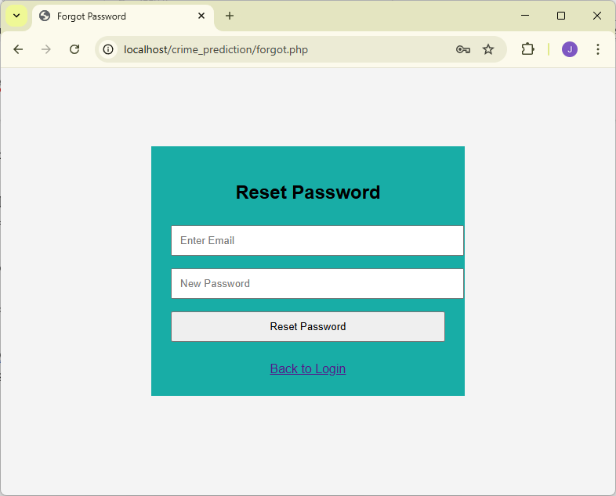

DASHBOARD.PHP
<?php
session_start();
if(!isset($_SESSION['uid'])){
header("Location:index.html");
exit();
}
?>
<!DOCTYPE html>
<html>
<head>
<title>Dashboard</title>
<style>
body{background:url('a.jpeg');background-size:cover;}
.box{width:350px;margin:100px auto;background:#18ada6;padding:25px;text-align:center;}
.btn{display:block;padding:10px;margin:10px 0;background:#007bff;color:white;text-decoration:none;}
</style>
</head>
<body>
<div class="box">
<h2>Crime Dashboard</h2>
<a href="children.html" class="btn">Children Crime</a>
<a href="types.html" class="btn">Types Crime</a>
<a href="logout.php" class="btn" style="background:red;">Logout</a>
</div>
</body>
</html>

LOGOUT.PHP
<?php
session_start();
session_destroy();
header("Location:index.html");
exit();
?>

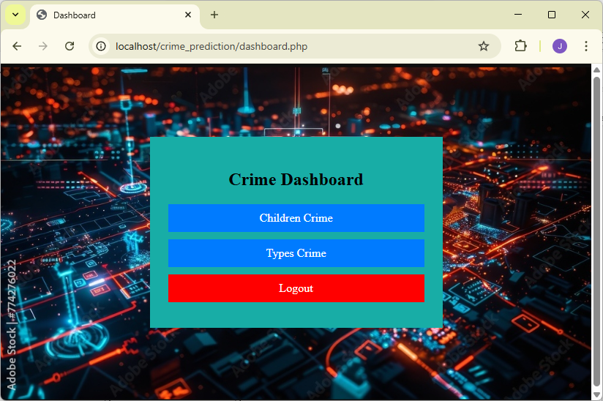

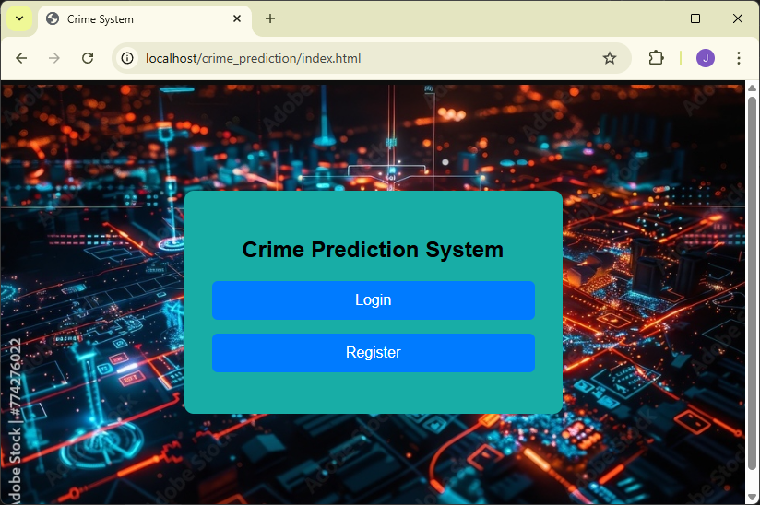

CHILDREN.HTML
<?php include "db.php"; ?>
<!DOCTYPE html>
<html>
<head>
<title>Children Crime Prediction</title>
<style>
body {
background-image: url('a.jpeg');
background-position: cover;

background-size: cover;
}

.box{width:420px;margin:80px auto;background:#667eea;padding:20px;}
select,button{width:100%;padding:8px;margin-top:10px;}
</style>
</head>
<body>

<div class="box">
<h2>Children Crime Prediction</h2>

<form action="children_predict.php" method="post">

<!-- AREA : 4 -->
<select name="area" required>
<option value="">Select Area</option>
<option>Chennai</option>
<option>Coimbatore</option>
<option>Madurai</option>
<option>Salem</option>
</select>

<!-- CRIME : 3 -->
<select name="crime" required>
<option value="">Select Crime</option>
<option>Child Labour</option>
<option>Child Abuse</option>
<option>Kidnapping</option>
</select>

<!-- YEAR : 3 -->
<select name="year" required>
<option value="">Select Year</option>
<option>2026</option>
<option>2027</option>
<option>2028</option>
</select>

<button type="submit">Predict</button><br><br>
<a href="dashboard.php">Back</a>

</form>
</div>

</body>
</html>

CHILDREN_PREDICT.PHP
<?php
include "db.php";

if (!isset($_POST['area'], $_POST['crime'], $_POST['year'])) {
die("Invalid input");
}

$area = trim($_POST['area']);
$crime = trim($_POST['crime']);
$year = (int)$_POST['year'];

$sql = "SELECT year, cases FROM children_crimes
WHERE area='$area'
AND crime_type='$crime'
ORDER BY year DESC
LIMIT 5";

$res = $conn->query($sql);

$total = 0;
$count = 0;
$latestYear = 0;

while ($row = $res->fetch_assoc()) {
$total += $row['cases'];
$count++;
if ($row['year'] > $latestYear) {
$latestYear = $row['year'];
}
}

if ($count == 0) {
die("No records found");
}

$avg = $total / $count;

/* Year difference */
$diff = $year - $latestYear;
if ($diff < 0) $diff = 0;

/* Zig-zag pattern */
if ($diff == 1) {
$adjust = 18;
$trend = "Slight increase compared to recent years.";
} elseif ($diff == 2) {
$adjust = -10;
$trend = "Temporary dip observed based on recent trend changes.";
} elseif ($diff >= 3) {
$adjust = 25;
$trend = "Projected rise due to long-term upward pattern.";
} else {
$adjust = 0;
$trend = "Stable trend compared to last recorded years.";
}

$prediction = round($avg + $adjust);

echo "<div style='background-color:#d4edda;
padding:20px;
width:400px;
margin:50px auto;
border-radius:10px;'>";

echo "<h2>Children Crime Prediction</h2>";
echo "Area : $area<br>";
echo "Crime : $crime<br>";
echo "Predicted Cases for $year : <b>$prediction</b><br><br>";
echo "<b>Reason:</b> $trend";
echo "<button onclick='history.back()'
style='padding:8px 15px;
background:#007bff;
color:white;
border:none;
border-radius:5px;
cursor:pointer;'>
Back
</button>";
echo "</div>";
?>
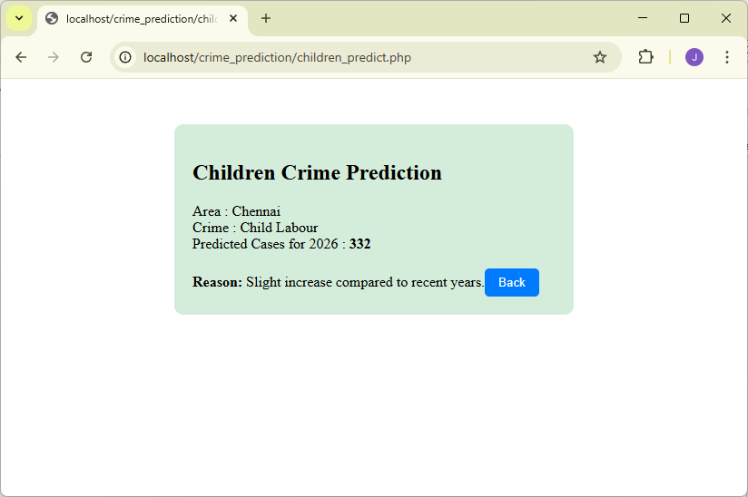
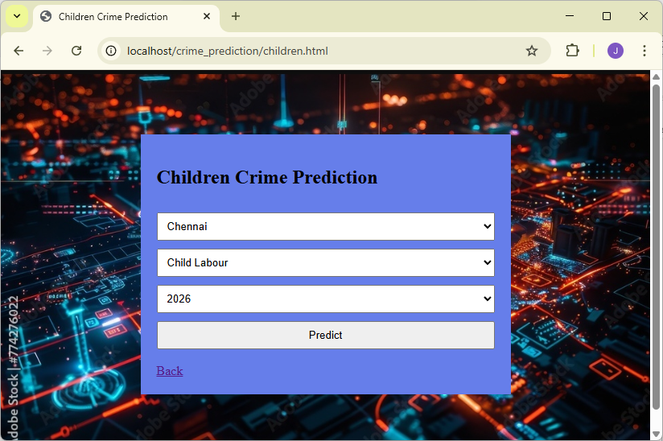
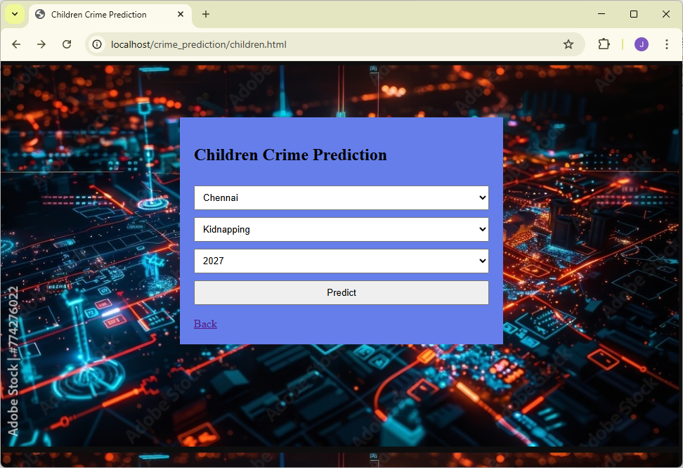
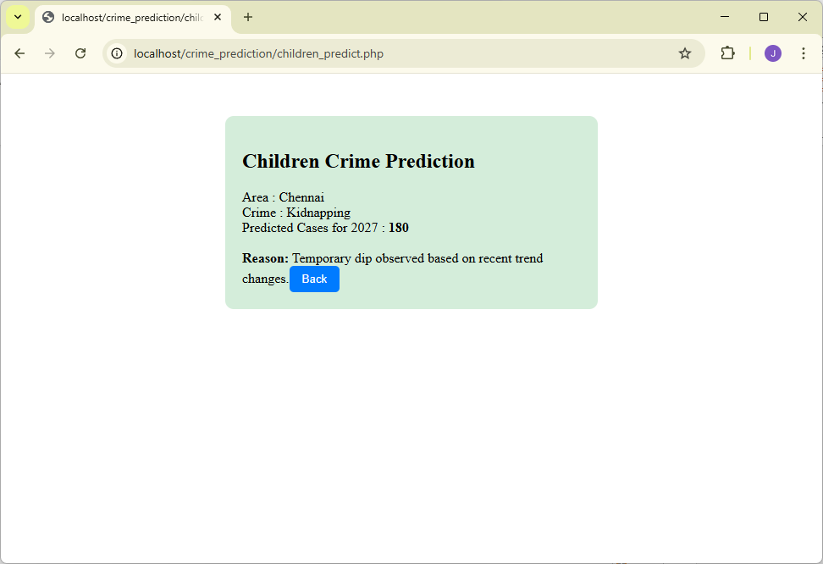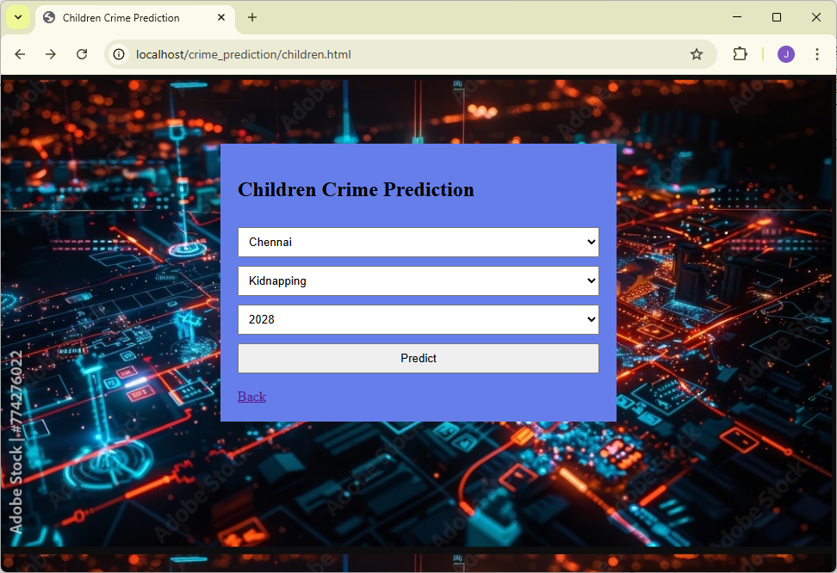
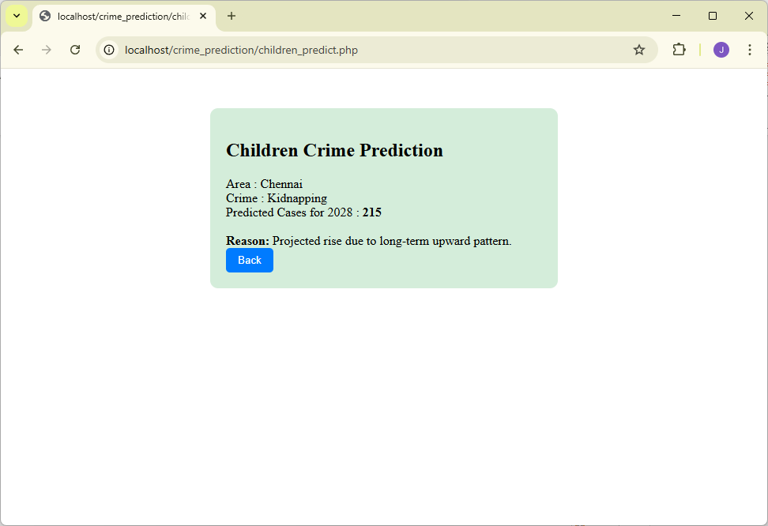
TYPES.HTML
<?php include "db.php"; ?>
<!DOCTYPE html>
<html>
<head>
<title>Crime Types Prediction</title>
<style>
body {
background-image: url('a.jpeg');
background-position: cover;

background-size: cover;
}

.box{width:420px;margin:80px auto;background:#667eea;padding:20px;}
select,button{width:100%;padding:8px;margin-top:10px;}
</style>
</head>
<body>

<div class="box">
<h2>Crime Types Prediction</h2>

<form action="types_predict.php" method="post">

<!-- AREA : 4 -->
<select name="area" required>
<option value="">Select Area</option>
<option>Chennai</option>
<option>Coimbatore</option>

</select>

<!-- CRIME : 3 -->
<select name="crime" required>
<option value="">Select Crime</option>
<option>Cyber Crime</option>
<option>Theft</option>
<option>Assault</option>
</select>

<!-- YEAR : 3 -->
<select name="year" required>
<option value="">Select Year</option>
<option>2026</option>
<option>2027</option>
<option>2028</option>
</select>

<button type="submit">Predict</button><br><br>
<a href="dashboard.php">Back</a>

</form>
</div>

</body>
</html>

TYPES_PREDICT.PHP
<?php
include "db.php";

if (!isset($_POST['area'], $_POST['crime'], $_POST['year'])) {
die("Invalid input");
}

$area = trim($_POST['area']);
$crime = trim($_POST['crime']);
$year = (int)$_POST['year'];

$sql = "SELECT year, cases FROM types_crimes
WHERE area='$area'
AND crime_type='$crime'
ORDER BY year DESC
LIMIT 5";

$res = $conn->query($sql);

$total = 0;
$count = 0;
$latestYear = 0;

while ($row = $res->fetch_assoc()) {
$total += $row['cases'];
$count++;
if ($row['year'] > $latestYear) {
$latestYear = $row['year'];
}
}

if ($count == 0) {
die("No records found");
}

$avg = $total / $count;

/* Year difference */
$diff = $year - $latestYear;
if ($diff < 0) $diff = 0;

/* Zig-zag pattern */
if ($diff == 1) {
$adjust = 25;
$trend = "Increase expected due to rising digital or urban activity.";
} elseif ($diff == 2) {
$adjust = -15;
$trend = "Short-term reduction predicted based on recent enforcement patterns.";
} elseif ($diff >= 3) {
$adjust = 35;
$trend = "Long-term growth projected from historical upward trend.";
} else {
$adjust = 0;
$trend = "Stable pattern compared to recent records.";
}

$prediction = round($avg + $adjust);
echo "<div style='background-color:#d4edda;
padding:20px;
width:400px;
margin:50px auto;
border-radius:10px;'>";
echo "<h2>Children Crime Prediction</h2>";
echo "Area : $area<br>";
echo "Crime : $crime<br>";
echo "Predicted Cases for $year : <b>$prediction</b><br><br>";
echo "<b>Reason:</b> $trend";
echo "<button onclick='history.back()'
style='padding:8px 15px;
background:#007bff;
color:white;
border:none;
border-radius:5px;
cursor:pointer;'>
Back
</button>";
echo "</div>";
?>

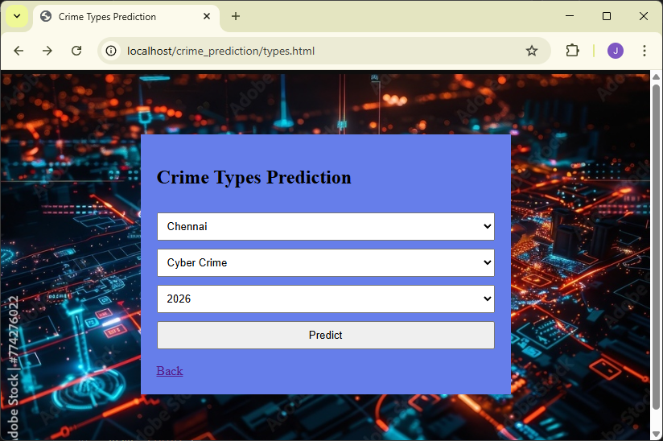
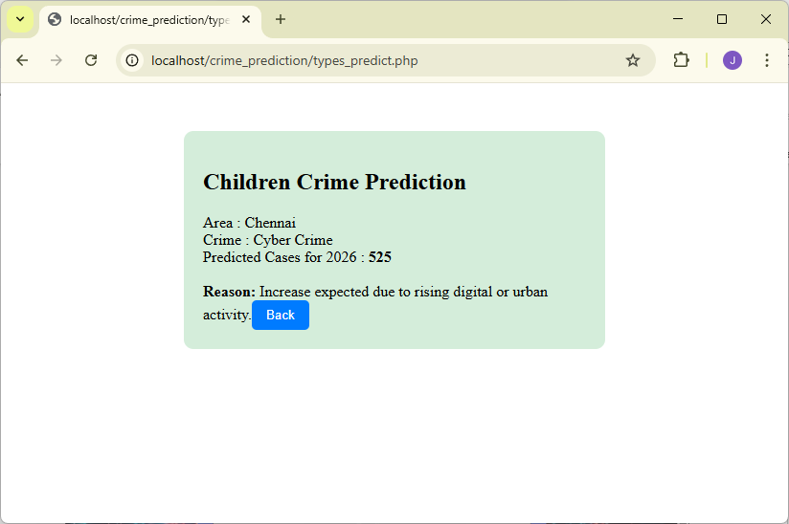

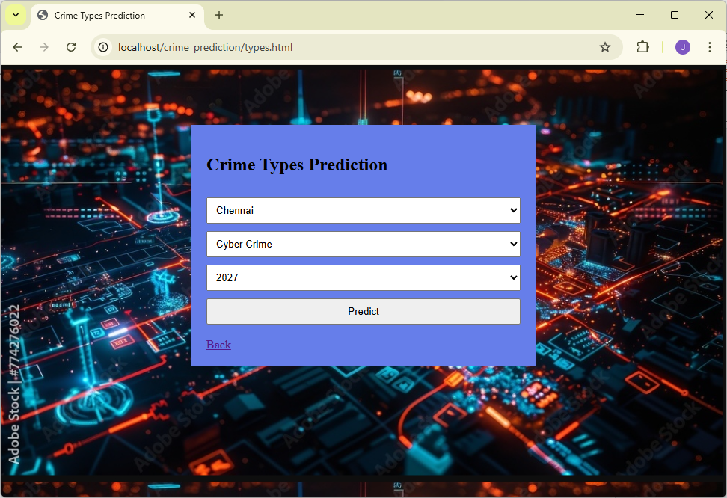
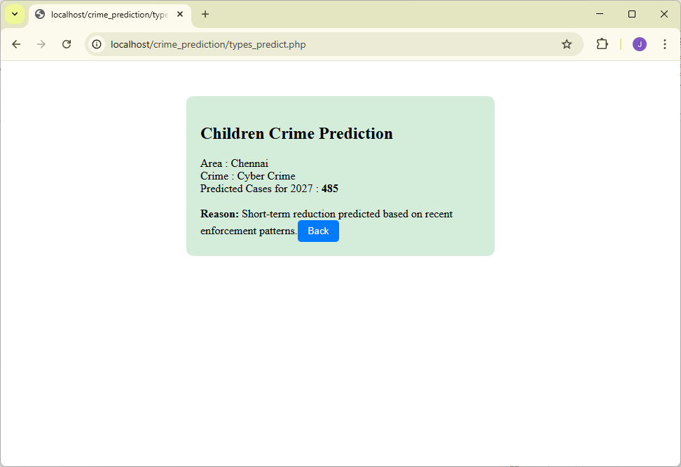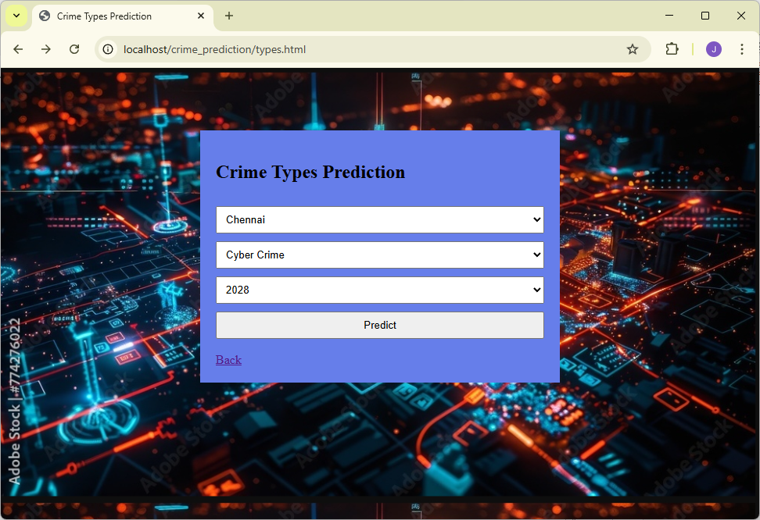
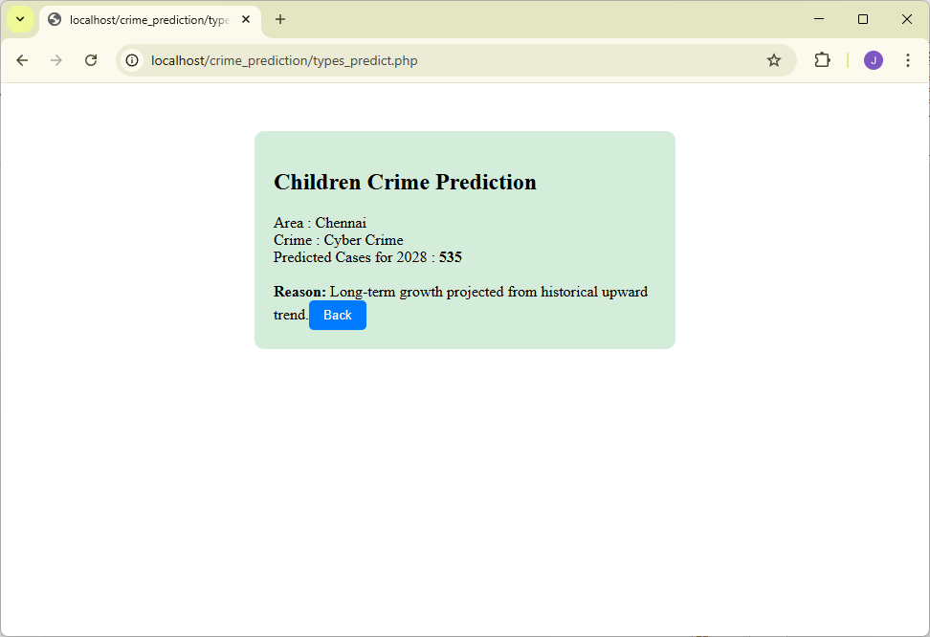
DATABASE.SQL
CREATE DATABASE children_crimes:

CREATE TABLE `children_crimes` (
`id` int(11) NOT NULL auto_increment,
`year` int(11) NOT NULL,
`area` varchar(40) NOT NULL,
`crime_type` varchar(40) NOT NULL,
`cases` int(11) NOT NULL,
PRIMARY KEY (`id`)
) ;
INSERT INTO `children_crimes` (`id`, `year`, `area`, `crime_type`, `cases`) VALUES
(1, 2016, 'Chennai', 'Child Labour', 210),
(2, 2017, 'Chennai', 'Child Labour', 225),
(3, 2018, 'Chennai', 'Child Labour', 245),
(4, 2019, 'Chennai', 'Child Labour', 265),
(5, 2020, 'Chennai', 'Child Labour', 250),
(6, 2021, 'Chennai', 'Child Labour', 270),
(7, 2022, 'Chennai', 'Child Labour', 295),
(8, 2023, 'Chennai', 'Child Labour', 315),
(9, 2024, 'Chennai', 'Child Labour', 335),
(10, 2025, 'Chennai', 'Child Labour', 355),
(11, 2016, 'Chennai', 'Child Abuse', 150),
(12, 2017, 'Chennai', 'Child Abuse', 165),
(13, 2018, 'Chennai', 'Child Abuse', 180),
(14, 2019, 'Chennai', 'Child Abuse', 200),
(15, 2020, 'Chennai', 'Child Abuse', 190),
(16, 2021, 'Chennai', 'Child Abuse', 210),
(17, 2022, 'Chennai', 'Child Abuse', 230),
(18, 2023, 'Chennai', 'Child Abuse', 250),
(19, 2024, 'Chennai', 'Child Abuse', 270),
(20, 2025, 'Chennai', 'Child Abuse', 290),
(21, 2016, 'Chennai', 'Kidnapping', 90),
(22, 2017, 'Chennai', 'Kidnapping', 100),
(23, 2018, 'Chennai', 'Kidnapping', 120),
(24, 2019, 'Chennai', 'Kidnapping', 140),
(25, 2020, 'Chennai', 'Kidnapping', 130),
(26, 2021, 'Chennai', 'Kidnapping', 150),
(27, 2022, 'Chennai', 'Kidnapping', 170),
(28, 2023, 'Chennai', 'Kidnapping', 190),
(29, 2024, 'Chennai', 'Kidnapping', 210),
(30, 2025, 'Chennai', 'Kidnapping', 230),
(31, 2016, 'Coimbatore', 'Child Labour', 180),
(32, 2017, 'Coimbatore', 'Child Labour', 195),
(33, 2018, 'Coimbatore', 'Child Labour', 215),
(34, 2019, 'Coimbatore', 'Child Labour', 235),
(35, 2020, 'Coimbatore', 'Child Labour', 220),
(36, 2021, 'Coimbatore', 'Child Labour', 240),
(37, 2022, 'Coimbatore', 'Child Labour', 260),
(38, 2023, 'Coimbatore', 'Child Labour', 280),
(39, 2024, 'Coimbatore', 'Child Labour', 300),
(40, 2025, 'Coimbatore', 'Child Labour', 320),
(41, 2016, 'Coimbatore', 'Child Abuse', 120),
(42, 2017, 'Coimbatore', 'Child Abuse', 135),
(43, 2018, 'Coimbatore', 'Child Abuse', 150),
(44, 2019, 'Coimbatore', 'Child Abuse', 165),
(45, 2020, 'Coimbatore', 'Child Abuse', 160),
(46, 2021, 'Coimbatore', 'Child Abuse', 175),
(47, 2022, 'Coimbatore', 'Child Abuse', 190),
(48, 2023, 'Coimbatore', 'Child Abuse', 205),
(49, 2024, 'Coimbatore', 'Child Abuse', 220),
(50, 2025, 'Coimbatore', 'Child Abuse', 240),
(51, 2016, 'Coimbatore', 'Kidnapping', 70),
(52, 2017, 'Coimbatore', 'Kidnapping', 85),
(53, 2018, 'Coimbatore', 'Kidnapping', 100),
(54, 2019, 'Coimbatore', 'Kidnapping', 115),
(55, 2020, 'Coimbatore', 'Kidnapping', 110),
(56, 2021, 'Coimbatore', 'Kidnapping', 125),
(57, 2022, 'Coimbatore', 'Kidnapping', 140),
(58, 2023, 'Coimbatore', 'Kidnapping', 155),
(59, 2024, 'Coimbatore', 'Kidnapping', 170),
(60, 2025, 'Coimbatore', 'Kidnapping', 190),
(61, 2016, 'Madurai', 'Child Labour', 150),
(62, 2017, 'Madurai', 'Child Labour', 165),
(63, 2018, 'Madurai', 'Child Labour', 180),
(64, 2019, 'Madurai', 'Child Labour', 195),
(65, 2020, 'Madurai', 'Child Labour', 190),
(66, 2021, 'Madurai', 'Child Labour', 205),
(67, 2022, 'Madurai', 'Child Labour', 220),
(68, 2023, 'Madurai', 'Child Labour', 235),
(69, 2024, 'Madurai', 'Child Labour', 250),
(70, 2025, 'Madurai', 'Child Labour', 265),
(71, 2016, 'Madurai', 'Child Abuse', 95),
(72, 2017, 'Madurai', 'Child Abuse', 110),
(73, 2018, 'Madurai', 'Child Abuse', 125),
(74, 2019, 'Madurai', 'Child Abuse', 140),
(75, 2020, 'Madurai', 'Child Abuse', 135),
(76, 2021, 'Madurai', 'Child Abuse', 150),
(77, 2022, 'Madurai', 'Child Abuse', 165),
(78, 2023, 'Madurai', 'Child Abuse', 180),
(79, 2024, 'Madurai', 'Child Abuse', 195),
(80, 2025, 'Madurai', 'Child Abuse', 215),
(81, 2016, 'Madurai', 'Kidnapping', 55),
(82, 2017, 'Madurai', 'Kidnapping', 70),
(83, 2018, 'Madurai', 'Kidnapping', 85),
(84, 2019, 'Madurai', 'Kidnapping', 100),
(85, 2020, 'Madurai', 'Kidnapping', 95),
(86, 2021, 'Madurai', 'Kidnapping', 110),
(87, 2022, 'Madurai', 'Kidnapping', 125),
(88, 2023, 'Madurai', 'Kidnapping', 140),
(89, 2024, 'Madurai', 'Kidnapping', 155),
(90, 2025, 'Madurai', 'Kidnapping', 175),
(91, 2016, 'Salem', 'Child Labour', 130),
(92, 2017, 'Salem', 'Child Labour', 145),
(93, 2018, 'Salem', 'Child Labour', 160),
(94, 2019, 'Salem', 'Child Labour', 175),
(95, 2020, 'Salem', 'Child Labour', 170),
(96, 2021, 'Salem', 'Child Labour', 185),
(97, 2022, 'Salem', 'Child Labour', 200),
(98, 2023, 'Salem', 'Child Labour', 215),
(99, 2024, 'Salem', 'Child Labour', 230),
(100, 2025, 'Salem', 'Child Labour', 245),
(101, 2016, 'Salem', 'Child Abuse', 85),
(102, 2017, 'Salem', 'Child Abuse', 100),
(103, 2018, 'Salem', 'Child Abuse', 115),
(104, 2019, 'Salem', 'Child Abuse', 130),
(105, 2020, 'Salem', 'Child Abuse', 125),
(106, 2021, 'Salem', 'Child Abuse', 140),
(107, 2022, 'Salem', 'Child Abuse', 155),
(108, 2023, 'Salem', 'Child Abuse', 170),
(109, 2024, 'Salem', 'Child Abuse', 185),
(110, 2025, 'Salem', 'Child Abuse', 205),
(111, 2016, 'Salem', 'Kidnapping', 45),
(112, 2017, 'Salem', 'Kidnapping', 60),
(113, 2018, 'Salem', 'Kidnapping', 75),
(114, 2019, 'Salem', 'Kidnapping', 90),
(115, 2020, 'Salem', 'Kidnapping', 85),
(116, 2021, 'Salem', 'Kidnapping', 100),
(117, 2022, 'Salem', 'Kidnapping', 115),
(118, 2023, 'Salem', 'Kidnapping', 130),
(119, 2024, 'Salem', 'Kidnapping', 145),
(120, 2025, 'Salem', 'Kidnapping', 165);

CREATE TABLE `types_crimes` (
`id` int(11) NOT NULL auto_increment,
`year` int(11) NOT NULL,
`area` varchar(40) NOT NULL,
`crime_type` varchar(40) NOT NULL,
`cases` int(11) NOT NULL,
PRIMARY KEY (`id`)
) ;
INSERT INTO `types_crimes` (`id`, `year`, `area`, `crime_type`, `cases`) VALUES
(1, 2016, 'Chennai', 'Cyber Crime', 280),
(2, 2017, 'Chennai', 'Cyber Crime', 310),
(3, 2018, 'Chennai', 'Cyber Crime', 340),
(4, 2019, 'Chennai', 'Cyber Crime', 370),
(5, 2020, 'Chennai', 'Cyber Crime', 390),
(6, 2021, 'Chennai', 'Cyber Crime', 420),
(7, 2022, 'Chennai', 'Cyber Crime', 460),
(8, 2023, 'Chennai', 'Cyber Crime', 500),
(9, 2024, 'Chennai', 'Cyber Crime', 540),
(10, 2025, 'Chennai', 'Cyber Crime', 580),
(11, 2016, 'Chennai', 'Theft', 520),
(12, 2017, 'Chennai', 'Theft', 550),
(13, 2018, 'Chennai', 'Theft', 580),
(14, 2019, 'Chennai', 'Theft', 610),
(15, 2020, 'Chennai', 'Theft', 590),
(16, 2021, 'Chennai', 'Theft', 620),
(17, 2022, 'Chennai', 'Theft', 650),
(18, 2023, 'Chennai', 'Theft', 680),
(19, 2024, 'Chennai', 'Theft', 710),
(20, 2025, 'Chennai', 'Theft', 740),
(21, 2016, 'Chennai', 'Assault', 300),
(22, 2017, 'Chennai', 'Assault', 325),
(23, 2018, 'Chennai', 'Assault', 350),
(24, 2019, 'Chennai', 'Assault', 380),
(25, 2020, 'Chennai', 'Assault', 370),
(26, 2021, 'Chennai', 'Assault', 400),
(27, 2022, 'Chennai', 'Assault', 430),
(28, 2023, 'Chennai', 'Assault', 460),
(29, 2024, 'Chennai', 'Assault', 490),
(30, 2025, 'Chennai', 'Assault', 520),
(31, 2016, 'Coimbatore', 'Cyber Crime', 190),
(32, 2017, 'Coimbatore', 'Cyber Crime', 210),
(33, 2018, 'Coimbatore', 'Cyber Crime', 235),
(34, 2019, 'Coimbatore', 'Cyber Crime', 260),
(35, 2020, 'Coimbatore', 'Cyber Crime', 275),
(36, 2021, 'Coimbatore', 'Cyber Crime', 300),
(37, 2022, 'Coimbatore', 'Cyber Crime', 325),
(38, 2023, 'Coimbatore', 'Cyber Crime', 350),
(39, 2024, 'Coimbatore', 'Cyber Crime', 375),
(40, 2025, 'Coimbatore', 'Cyber Crime', 400),
(41, 2016, 'Coimbatore', 'Theft', 410),
(42, 2017, 'Coimbatore', 'Theft', 435),
(43, 2018, 'Coimbatore', 'Theft', 460),
(44, 2019, 'Coimbatore', 'Theft', 490),
(45, 2020, 'Coimbatore', 'Theft', 470),
(46, 2021, 'Coimbatore', 'Theft', 500),
(47, 2022, 'Coimbatore', 'Theft', 530),
(48, 2023, 'Coimbatore', 'Theft', 560),
(49, 2024, 'Coimbatore', 'Theft', 590),
(50, 2025, 'Coimbatore', 'Theft', 620),
(51, 2016, 'Coimbatore', 'Assault', 220),
(52, 2017, 'Coimbatore', 'Assault', 245),
(53, 2018, 'Coimbatore', 'Assault', 270),
(54, 2019, 'Coimbatore', 'Assault', 300),
(55, 2020, 'Coimbatore', 'Assault', 290),
(56, 2021, 'Coimbatore', 'Assault', 320),
(57, 2022, 'Coimbatore', 'Assault', 350),
(58, 2023, 'Coimbatore', 'Assault', 380),
(59, 2024, 'Coimbatore', 'Assault', 410),
(60, 2025, 'Coimbatore', 'Assault', 440);

CREATE TABLE `users` (
`id` int(11) NOT NULL auto_increment,
`name` varchar(100) default NULL,
`email` varchar(100) default NULL,
`password` varchar(255) default NULL,
`role` varchar(20) default NULL,
PRIMARY KEY (`id`),
UNIQUE KEY `email` (`email`)
) ;
INSERT INTO `users` (`id`, `name`, `email`, `password`, `role`) VALUES
(1, 'J', 'p@gmail.com', 'c4950298c3236fd9ee35782b043e9365', 'user'),
(2, 'ad', 'admin@gmail.com', '823f4cfe556f95863e2df595c02b432f', 'admin');

